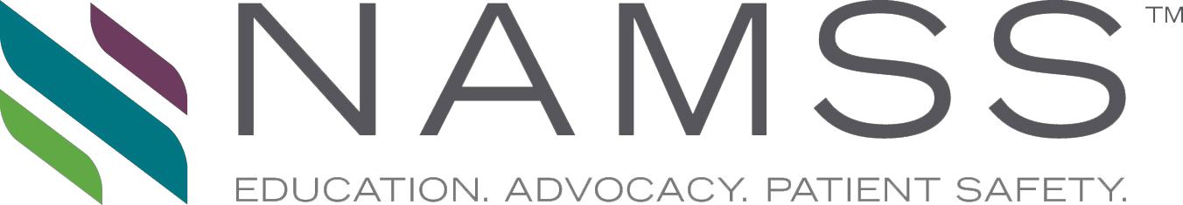

NATIONAL ASSOCIATION MEDICAL STAFF SERVICES

Certifies That

Successfully Completed

***Gateway* Article: Title**

Sponsored by: National Association Medical Staff Services

on

Publication Date

And is hereby awarded 1.0NAMSS continuing education credits

Accreditation of this educational program

in no way implies endorsement or sponsorship by NAMSS

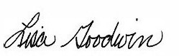

Lisa Goodwin, MBA, CPCS, CPMSM Chair, NAMSS Professional Development Council